**CHARLITON MAMBEYI – SCII/01361/2018**

**FITNESS HUB**

**PROJECT SCOPE**

**September 18, 2022**

# OVERVIEW

## 1. PROJECT BACKGROUND AND DESCRIPTION

Over the past few years, living a healthy lifestyle has become trendy. Nowadays, being healthy means being beautiful, successful, and fit. People are becoming increasingly aware of diseases caused by obesity and sedentary office work. These and other health-related problems encourage millions of people around the world to do sports. That’s why fitness web app development is so popular today.

The purpose of this fitness web app is to;

* Provide the user with instructions and examples of one or more types of exercise and physical activity.
* Allow the user to create a plan of each exercise per day.
* Allow a user to search for any exercise.
* Provide similar exercises related to the one a user wants.
* Provide video demonstrations of exercises from YouTube.
* Learning about diet required during exercises.

## 2. PROJECT SCOPE

In order to achieve the above named, the project will implement the following functionalities that are in scope: -

* User Authentication.
* User can search for any exercise he or she wants.
* User can create a plan to record exercises performed on each date.
* User can have recommended meals to help him through his or her exercises.

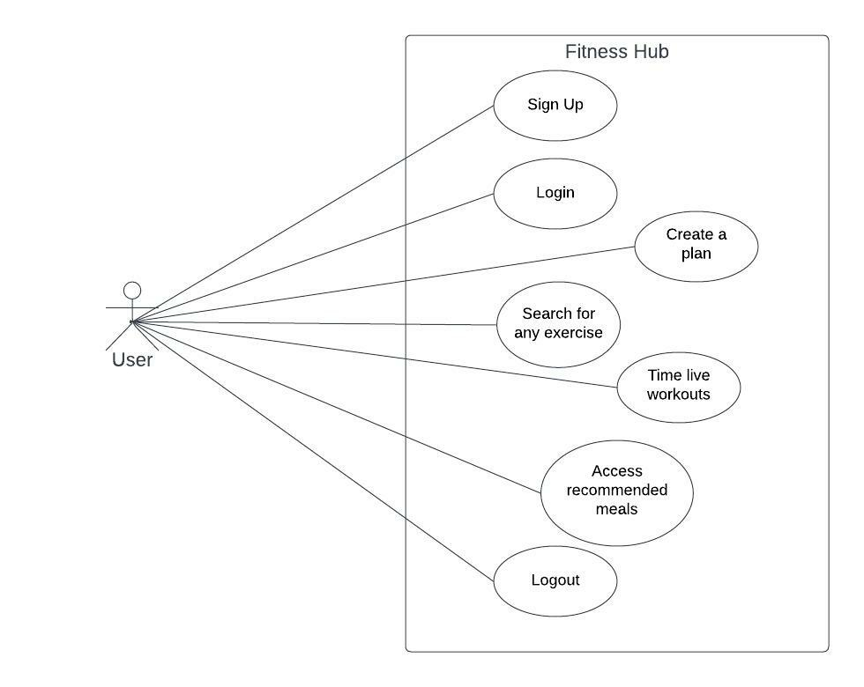

The functionalities that will be implemented at a high level are: -

**Exercise Module**

This module constitute of various exercises users need to access. The users can search for the exercises using the name of the exercise or a body part associated with the exercises. This will return a gif representation of several exercises to help the user select one of them. Upon selection, the user will be able to get a brief description of that particular exercise. The user will also be recommended similar exercises to that which he searched for.

**Food Module**

This module allows the users to create a meal with existing foods stored in the database in order to keep track of the nutrition intake. If a person is facing trouble with the time sticking to healthy nutrition, the app will help to create grocery shopping lists and even collect healthy meals. The system will just recommend some meals suitable for users to eat based on their goals.

**Plan Module**

The plan module enables users to create specific workouts they are supposed to carry out on specific days. The workouts will be saved in a calendar view and each day will be assigned specific workouts. A fitness plan is a schedule of planned sessions of physical exercise. This plan will guide the user on his day to day exercises that he needs to perform, and they will be saved on a daily basis.

**Timer Module**

Whether you run a gym or like to exercise at home, you should have a reliable way to keep track of the time. This metric is useful for creating structure and adding measurability to workouts so that you can continually improve and reach goals with strength and endurance exercises alike. The best way to break up exercise without needing to constantly look at a regular clock while you’re in the middle of difficult movements is to use a timer clock. It will give you an auditory and visual signal that will tell you when to start and stop activities.

## 3. HIGH-LEVEL REQUIREMENTS

System requirements - They include minimum memory requirements of 4GB RAM, The system will run on any windows platform and it will communicate with the firebase database. A hard disk capacity of minimum 500 GB is required.

User requirements – The system will have a user friendly user interface to make it easier for users to navigate through the system easily. Also, many users can use the system concurrently without noticeable delays.

## 4. DELIVERABLES

* Firebase database
* Users’ responsive web based application
* UI prototype for users
* User documentation manual.
* Technical documentation

## 5. AFFECTED PARTIES

* Registered Users

## 6. AFFECTED BUSINESS PROCESSES OR SYSTEMS

* User signup and login
* Exercise search
* Creating a plan
* Meal recommendation
* Timer for workout
* Recommending similar workouts

## 7. SPECIFIC EXCLUSIONS FROM SCOPE

The following will be excluded from the scope;

* Integrating social platform buttons to enable users to share their posts, goals, and results with their social networks.
* Integrating location feature that allows the user to track his walking routes, and to build them and record workouts.
* A push notification to remind users of their workout session and enable them work out regularly and never miss a session.

## 8. IMPLEMENTATION PLAN

The project will kick off with developing a design representation of the project UI using Figma. This design will cover all UI aspects of the project.

Then development will start with authentication, which involves the implementation of registration of users and storing their data in a database. In this process the database will be set up and connected with the system so that it interacts with the system.

Then the exercise module will be implemented to enable searching and recommendation of similar exercises. Videos will be integrated for demonstration.

The plan module will then be implemented to enable, together with the food module to enable users create their schedule and recommend them meals respectively.

The timer module will also be implemented to time duration of performing some exercises. Finally the system will be tested and launched for it to be used.

## 9. HIGH-LEVEL TIMELINE/SCHEDULE

|  |  |  |  |  |
| --- | --- | --- | --- | --- |
| # | Date | Description | Dep. | Comments |
| **1** | 22/9/2022 – 25/9/2022 | Wireframes |  |  |
| **2** | 63/9/2022 – 04/10/2022 | Signup and login implementation | #1 |  |
| **3** | 05/10/2022 – 13/10/2022 | Exercise module implementation | #2 |  |
| **4** | 14/10/2022 – 25/10/2022 | Plan module implementation | #3 |  |
| **5** | 26/10/2022 – 07/11/2022 | Food module implementation | #4 |  |
| **6** | 08/11/2022 – 15/11/2022 | Timer module implementation | #5 |  |
| **6** | 16/11/2022 – 20/11/2022 | Launching the web | #6 |  |

# Approval and Authority to Proceed

We approve the project as described above, and authorize the team to proceed.

|  |  |  |  |
| --- | --- | --- | --- |
| Name | Title | Signature | Date |
| Felix Otieno Okoth | Mr. |  | 22/9/2022 |
|  |  |  |  |

|  |  |  |  |  |  |  |  |  |
| --- | --- | --- | --- | --- | --- | --- | --- | --- |
|  |  |  |  |  |  |  |  |  |
| Approved By |  |  | Date |  | Approved By |  |  | Date |